Mack Hall

1/18/19

ECE 342 - Blue 1 | AC Bluetooth Switch

Prof. Shuman

Draft Interface & Property Definition Table and Tests

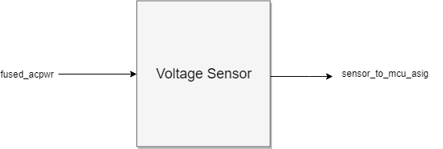

**Fig. 1.** Black Box Diagram of Voltage Sensor Block

**Table 1.** Voltage Sensor Block Interfaces and Properties

|  |  |
| --- | --- |
| Interface | Properties |
| fused_acpwr | VNominal: 120 VACrms:  VMax: 120 VACrms  INominal: 500mA  IMax: 5A  fNominal: 60 Hz |
| sensor_to_mcu_asig | VMax: 6 VDC  VNominalLow: 0.36 VDC  VNominalHigh: 5 VDC  VMin: -0.5 VDC |

**Testing Steps**

1. **Nominal Voltage Testing**

This block must be capable of measuring the voltage being supplied through the switch to the outlets.

1. Connect the voltage sensor block to the microcontroller block. Ensure that the microcontroller is able to produce an output that is readable by the tester.
2. Connect the voltage sensor block to the fuse block.
3. Connect the fuse block to **outside_to_system_acpwr**.
4. Probe input for a voltage reading.
5. Record readings from microcontroller.
6. Disconnect fuse block from **outside_to_system_acpwr**.
7. Repeat steps 1-2.
8. Generate an AC voltage source of 5 VACrms and 30Hz.
9. Connect to voltage sensor block.
10. Repeat steps 4-5.

PASS: This block passes if the microcontroller produces voltage readings between 117.6-122.4 VACrms for the 1st test (wall source) and voltage readings between 4.9-5.1 VACrms for the 2nd test (lab generated signal). The output has a maximum acceptable error of 2% for expected operating temperatures of the block.